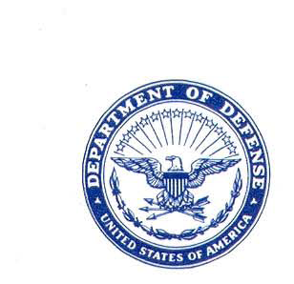 **DEPARTMENT OF DEFENSE**

**DCPAS Message 2024139**

**DEFENSE CIVILIAN PERSONNEL ADVISORY SERVICE**

**4800 MARK CENTER DRIVE**

**ALEXANDRIA, VA 22350-1100**

FOR: CIVILIAN PERSONNEL POLICY COUNCIL MEMBERS

FROM: Defense Civilian Personnel Advisory Service Director, Mr. Daniel J. Hester //Signed 12/19/2024//

SUBJECT: Introducing REACH-C (Resources Exist, Asking Can Help-Civilian): A New Mental Wellness Training for Department of Defense Civilian Personnel

AUDIENCE: DoD Appropriated Fund and Nonappropriated fund Civilian Employees and Supervisors

ACTION: Disseminate to Department of Defense (DoD) Human Resources Practitioners

REFERENCE: U.S. Office of Personnel Management (OPM) Memorandum, “Guidance on Mental Health Programs,” dated, May 24, 2024, <https://www.chcoc.gov/content/guidance-employee-wellness-programs>

BACKGROUND/INTENT: In accordance with the OPM memorandum at reference (1), we are introducing REACH-C, a new self-paced virtual training course that teaches essential mental health skills such as self- advocacy, social connection, work-life balance, and supporting colleagues in need, which aims to help employees manage stress and thrive both personally and professionally. Additionally, there is a supervisors’ module that focuses on building trust and promoting psychological safety to better lead teams.

The course was developed by the Defense Personnel Analytics Center (DPAC), in collaboration with the Defense Civilian Personnel Advisory Service (DCPAS), to address the Help-Seeking Paradox; many federal employees want help offered through their workplace, but only a small percentage of individuals use the resources that are available.

Components are asked to promote and encourage both employees and supervisors to complete this self- paced training. For more information and access to the REACH-C training, please visit: <https://www.dcpas.osd.mil/policy/worklife/employeeassistance/reach-c-training>

POINT OF CONTACTS: For questions or additional support, please contact Hollie Koutsalas, Senior Benefits & Work Life Programs Manager, hollie.r.koutsalas.civ@mail.mil.