URL: https://www.dcpas.osd.mil/policy/worklife
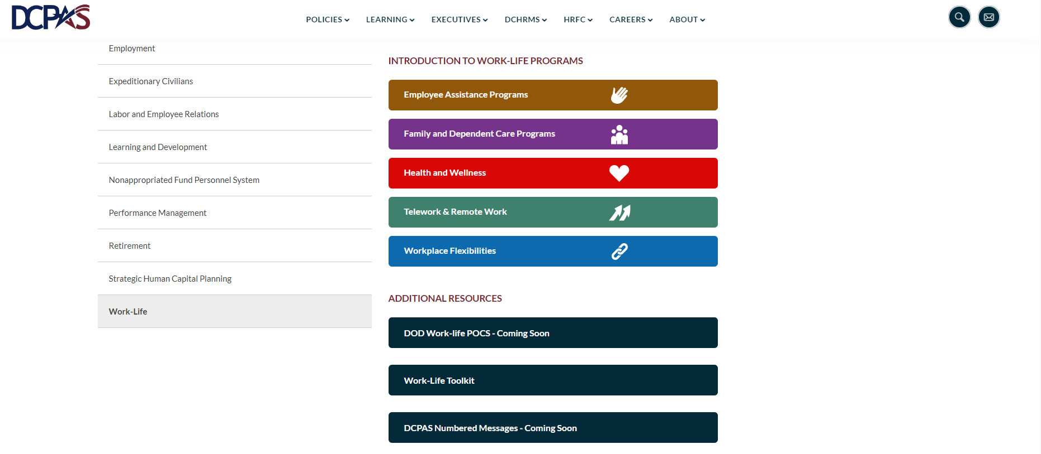

URL: https://www.dcpas.osd.mil/policy/worklife/telework
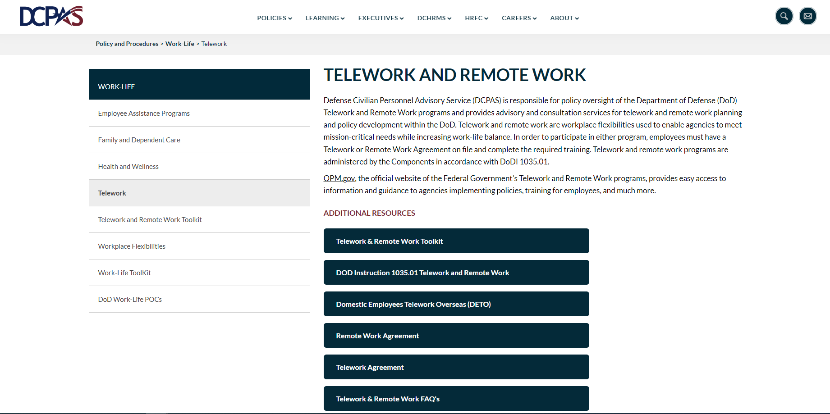
We want this tab (Domestic Employees Teleworking Overseas (DETO) Toolkit) to appear as an informational page like our Telework & Remote Work Toolkit tab, or like the website Military One Source - DETO Page.

URL: generate a new url because we are creating a new web page with content mirroring the Telework and Remote Work Toolkit format.
DOMESTIC EMPLOYEES TELEWORKING OVERSEAS (DETO) TOOLKIT
This toolkit provides information and resources for the Department of Defense (DOD) workforce to assist with implementing Component-specific DETO policy. A DETO is defined as a United States Government employee assigned to a domestic position with an alternative work arrangement permitting a work to be performed at an approved worksite in an overseas location for a limited period of time. This voluntary work arrangement benefits military spouses wishing to maintain their careers while keeping their families together when assigned to overseas locations. Employees interested in learning more about DETO opportunities within their Component should contact their designated Component Telework Coordinator.
- DOD INSTRUCTION 1035.01, “TELEWORK AND REMOTE WORK”
  - DOD Instruction 1035.01, “Telework and Remote,” establishes policy, assigns responsibilities, and prescribes procedures for implementing DOD telework and remote work programs. This policy replaces DOD Instruction 1035.01, “Telework Policy,” dated April 4, 2012.
  - Telework and Remote Work
- DOD MEMORANDUMS & DEPARTMENT OF STATE DETO GUIDANCE
  - The DoD Memorandum contains policy and Department of State guidance on DETO provisions that specify the requirements that must be incorporated in a DETO policy.
Department of State’s Domestic Employees Teleworking Overseas Policy Guidance

  - State-DoD DETO MOA – 17 APRIL 2024
- SAMPLE INTERAGENCY DETO AGREEMENT TEMPLATE
  - Interagency DETO Agreement Template
- DETO LOCALITY PAY
  - The FY 2023 National Defense Authorization Act (NDAA) includes a provision providing special locality pay to Civil Service DETOs.
  - DETO Locality Pay
- DETO COORDINATOR LISTING
  - Each DoD Component has Component-specific DETO policies and procedures that address the needs of their unique missions and workforce. DoD employees are encouraged to contact their Component’s DETO Coordinator for more information on their Component-specific DETO policy.
  - DETO Coordinators List
- DETO FAQs
  - What is a DETO?
A Domestic Employee Teleworking Overseas (DETO) is a United States Government (USG) employee assigned to a domestic position with an alternative work arrangement permitting work to be performed at an approved worksite in an overseas location for a limited period of time.
  - Who can approve a DETO?
The State Department must approve all DETO requests. DoD Components may develop their internal procedures to determine DETO eligibility. However, the Chief of Mission (COM) within each country where the work will take place has the ultimate authority to approve the arrangement. The circumstances of approvals will vary from country to country as well as from case to case.

  - Are DETO arrangements categorized as remote work?
No. DETOs are categorized as telework per the statutory changes to the National Defense Authorization Act for Fiscal Year 2022 (P.L. 117-81 § 6202), which required Federal agencies to establish DETO (Domestic Employees Teleworking Overseas) policies within their agency ‘telework requirements’ and to determine within those policies the circumstances in which an employee would be permitted to perform official duties from an approved overseas location temporarily. This provision amended 5 U.S.C. 6502 (the Telework Enhancement Act) to require all Executive agencies to include DETO policies within their telework policies.

  - What is the processing time for a review of a DETO request?
On average, DETO requests can take up to 6-9 months to review for final determination.

  - Is a DETO agreement required?
Yes. Employees are not authorized to perform the duties of a position whose regular worksite is located in the United States at an alternative worksite in a foreign location without an approved DETO agreement.

  - Can a DETO agreement be amended?
Yes. Supervisors may amend DETO agreements at any time by providing written justification based on the office’s needs and with prior notification of 90 days. Amended agreements must be routed through the State Department’s National Security Decision Directive 38 approval process for final approval determination by the Chief of Mission (COM).

  - Can a DETO agreement be terminated before its prescribed termination date?
Yes. Either the employee or supervisor may cancel a DETO agreement before its prescribed termination date. The notice of cancelation must be submitted, in writing, 90 calendar days before the effective date.

  - What is the April 17, 2024, Memorandum of Agreement between the Defense Department and the State Department?
The agreement improves the economic security of some military families by enabling eligible federal employees who accompany their Service member or DoD civilian spouses on assignments to military installations overseas to quickly be approved to work remotely, allowing more spouses to keep their federal jobs during permanent change of station (PCS) moves.

Under the MOA, the DoD will provide a range of required security services to covered DETOs that are normally carried out by regional security officers at U.S. embassies and consulates (e.g., emergency planning, evacuation assistance, initial incident response for serious incidents). Additionally, the State Department will accept DOD’s suitability determination for DETO residences and will not require additional inspections using State Department standards.

  - How does this MOA help military families?
Under this MOA, the DOD and the State Department will work together to facilitate approval of DETO arrangements for federal employees who are spouses of military and DOD civilian employee sponsors.

More federally employed spouses will be able to maintain their careers, improve their economic security and keep their families together while they accompany their service member or DOD civilian employee spouse overseas.

  - When will this MOA take effect?
The MOA took effect April 18, 2024.

  - What areas are covered under the MOA?
This MOA is limited to areas where DOD has approved assignments and where DOD has established Military Housing Offices serving the military installation community.

  - Where can I find more information about the DETO program?
DOD employees should reference Section 5 of DODI 1035.01, “Telework and Remote Work,” which contains policy for domestic employees temporarily working from overseas pursuant to DETO arrangements. Federal employees from other executive branch agencies should contact their DETO coordinator or human resources office.

  - How do military spouses who are federal employees start the DETO arrangement process?
Any military spouse who is an executive branch employee wanting to work overseas must first get approval by their supervisor in the agency where they work.

  - Do military spouses who already have an approved DETO arrangement need to start over?
No. The new MOA does not impact anyone working overseas with an approved DETO agreement.

  - Can military spouses work remotely while applying to work overseas under a DETO agreement?
Federal employees may not be approved to work remotely from a foreign location prior to obtaining approval from the State Department pursuant to the DETO program. They may be approved by their agency employer to telework or work remotely from locations within the United States.

  - Who pays for any enhancements that are needed to bring a non-DOD controlled residence into compliance with DOD safety and security criteria?
Employees or their employing agency may either pay to make necessary upgrades to meet the required standards or must find a different residence that meets required standards.
- ADDITIONAL RESOURCES
  - Executive Order 14100
  - Military One Source
Domestic Employees Teleworking Overseas Program Overview
  - 3 Foreign Affairs Manual (FAM) 2370
Domestic Employees Teleworking Overseas (DETO)
- 13 FAM 301.4
Mandatory Training Preparatory to Going Abroad
FACT FAQ PDF

